Interactive Activity sheet b13 for young children
SDGs: Quality Education 4, Responsible Consumption 12, Climate action13, life on land 15.
Looking at Trees
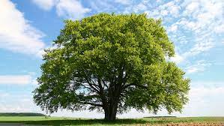
Trees are flowering plants which produce fruits and seeds. Trees are generally the biggest of the plants that we might find. They come in all sorts of different shapes depending on where they grow. This is because there are different climate conditions which enable the trees to grow. Climate conditions are the temperature, wind, the rainfall and the length of day and night.
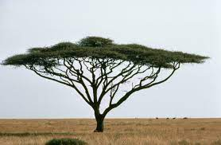
Trees usually have a firm trunk which is often covered in a woody bark. If you place a piece of paper on this bark and rub it with a wax crayon you will get the bark pattern on your paper. Every tree type is different. Trees have woody roots, which sometimes push up the ground around the base of the trunk. Roots reach into the ground. They help keep the tree standing up straight and can take in water and minerals. Can you find any places where the tree roots are pushing up the ground? Roots extend underground as far as branches above ground.
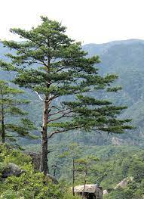
Trees are different shapes depending on the climate. Pointed pine trees are found in snowy areas so that snow slides off their leaves. More rounded shaped trees protect the ground beneath them from too much water. this is important and can prevent soil erosion.

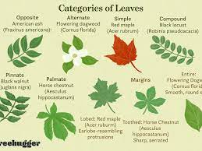
Trees have leaves of all shapes and sizes from spiny needles to very large leaves almost like small plates. In some countries these leaves are used for food plates. Find some tree leaves and draw round them. Needle shaped leaves protect the tree from the cold or very dry conditions. Some trees have spikes which protect them from being eaten.
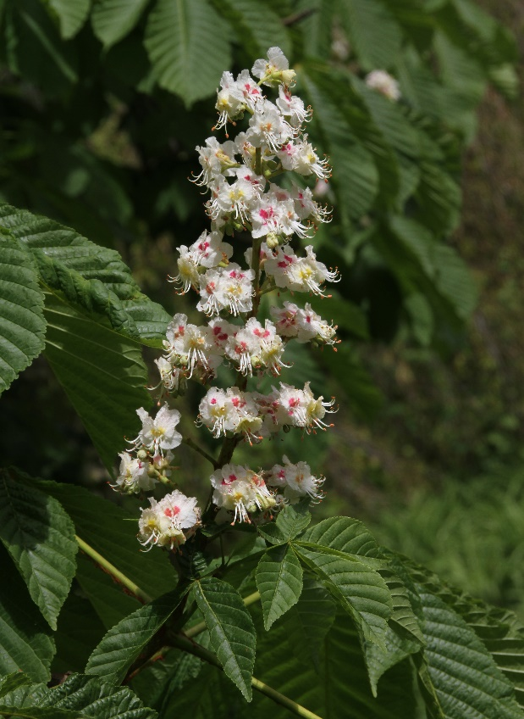
Trees have flowers though not always like we would expect flowers to look. Catkins are like that. They are male flowers and you need to look for the female flowers! Flowers contain pollen moved by insects or wind so that seeds can form inside a fruit. Some fruits form nuts that we eat as well as other fruits with seeds, oranges or apples or cocoa beans or jack fruit. What fruits and seeds do you eat from trees?
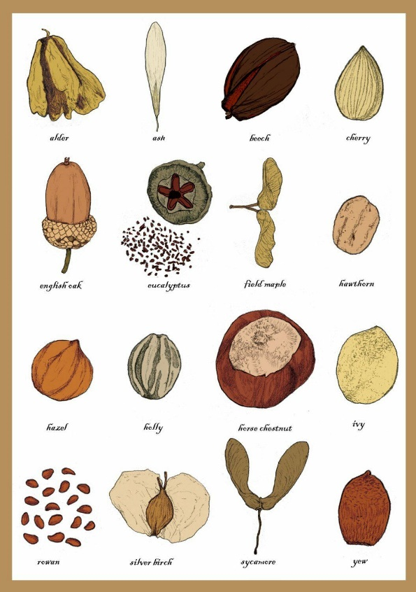
Trees take in carbon dioxide from the air and give out oxygen in exchange when they are using sunlight to make food. Trees are often called the lungs of the planet. We need to preserve our forests of trees to keep our air healthy and stop erosion. Planting new trees will help keep our planet’s temperature more stable by removing carbon dioxide.
Trees are very useful as their wood is used for buildings, furniture, fires and paper amongst other things. We need to be careful how much wood we use and make sure we keep planting more trees to replace any we use.
Copyright Sue and Denise

