Activity sheet 20
Communication 2
Sustainable Development Goals
11: sustainable cities and communications
4: quality education for all

Lets start off by doing some communication! Find a round coin and draw several circles on a piece of paper.
Fill them in with a happy face, a sad face and a face that you are going to ask someone if they can understand what it means. You are communicating!!

You might have seen traffic lights at road junctions – these are telling drivers something – to stop (with a red light) or they can move forward (a green light).
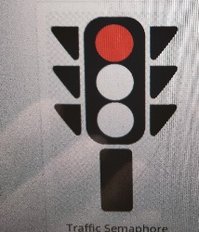

Railway lines have signals to tell the train drivers whether they can move forward safely too!
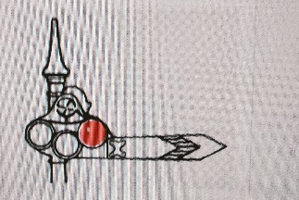
Have a look for these signals when you are outside.
In the past sailors had to communicate when they were at sea. They had two different ways of doing this. Firstly, sailors used two flags called semaphore flags. By waving these flags in different positions they could spell out different letters and send messages.

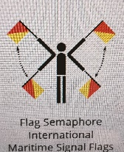

Ships also had many different flags, some plain colours, others stripes or patterns. Each flag meant something. The yellow flag meant that you had someone on board who was ill with a nasty disease, so other ships had to keep away. This yellow flag is still used as a warning today!

When radio signals were first used in the 1890s a new way of communication was invented called the Morse Code. Each letter of the alphabet is coded with dots and dashes or both. For example S is dot, dot, dot and O is dash, dash, dash. So the emergency signal SOS became dot, dot, dot, dash, dash, dash, dot,dot,dot.
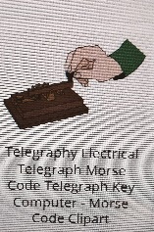

a grown up to find the signal in the morse code for the first letter of your name!
Here is a different type of communication code used. Each letter of the alphabet has an easy word. E becomes Echo, C is Charlie and D is Delta. Pilots communicate using this code and it is often used if you are spelling something – try saying your name in this code ( I have put the code on the second page) my name is Delta Echo November India Sierra Echo!)

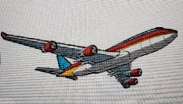
The Egyptians used pictures for communicating. These were called ‘hieroglyphics’. They carved the pictures onto stones and there is a very famous stone in the British Museum called the Rosetta Stone which has some of these early carvings. You can see fish, rivers and boats and lots of other things.

And finally!! Get a grownup to write down all the letters of the alphabet and use your own words for each letter – perhaps you can write a secret message to your friends.
So my name might have a picture of a dog (D) an egg (E), a nut (N), ice cream (I), a sun for (S) and another egg. What does your name look like?
Try making some hieroglyphics – you can draw a house or a tree or a car, and put them together to say my car is under a tree outside a house!
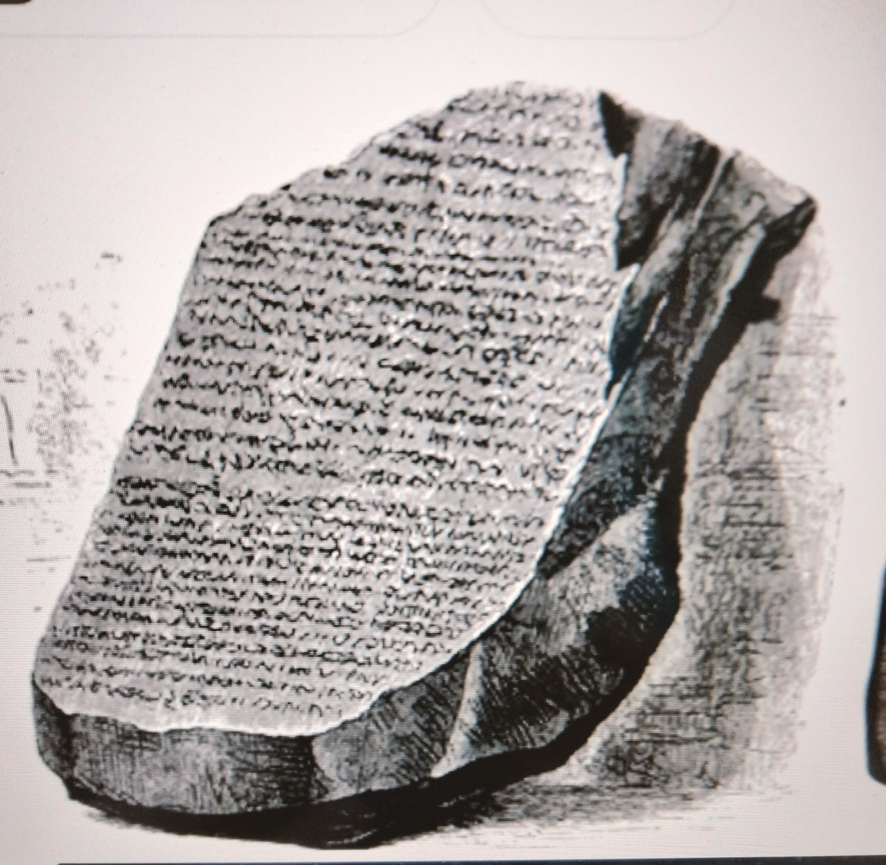
The Rosetta Stone
Can you make up a code alphabet? The Alphabet of the Air: Alpha, Bravo, Charlie , Delta, Echo, Foxtrot, Golf, Hotel, India, Juliet, Kilo. Lima, Mike, November, Oscar, Papa, Romeo, Sierra, Tango, Uniform, Victor, Whiskey, Xray, Zulu.

Enjoy communicating!
Denise 2023

