Innovative Activity sheet 12 Separation
We are going to look at Mixtures!. So to start, we need to understand what a mixture is. A mixture is something made up of different things that can be separated easily. If you have a bag of mixed sweets, you can tip them out and separate them into different piles. In each pile will be all the same sweets.
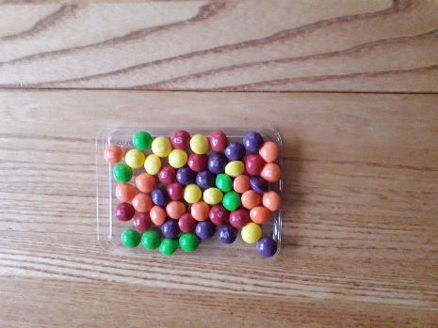
Mixture of sweets.
They might be all the same colour if you have emptied a tube of Smarties or M&Ms, or they could be toffees, chocolates and boiled sweets in the different piles. It is easy to sort these by hand.
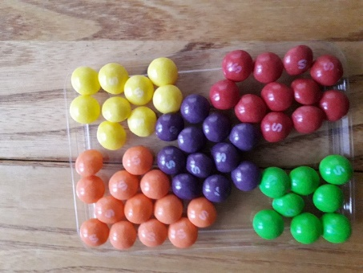
Sweets separated into colours.

Lets look at other things you might find easy to separate from a mixture. Suppose you have a handful of pencils and felt tip pens. You can easily sort these into separate groups. In your handful you might have coloured pencils, felt tips and lead pencils. Perhaps you could make these into three groups.
But what happens if you have something like rice mixed in with macaroni? I suppose you could sit down and pick out all the macaroni and you would be left with the rice grains. Can you think of an easier way?
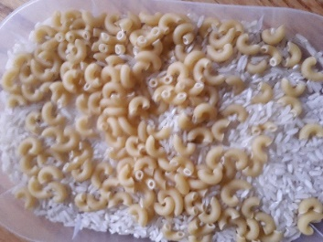
Hopefully you will think about sieving. A sieve is a piece of equipment you might find in the kitchen or in the garden or in a science room. It is something with holes in it that will allow small pieces to pass through and catch the bigger pieces. You might recognize some of these from the picture below.
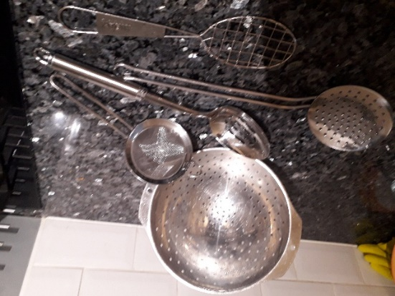

To separate the macaroni and rice, you could use the spoon as a sieve, as the rice grains will go through the holes but the macaroni won’t. You will finish up with a pile of macaroni and a pile of rice. Well done!
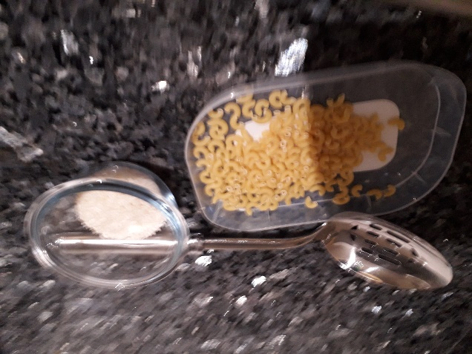
Suppose this time you have managed to mix up rice and flour. Which sieve would work this time?
Sieving is all about separating bigger bits from smaller bits. This time I used dried lentils and flour. It was a bit more difficult but worked with the sieve.
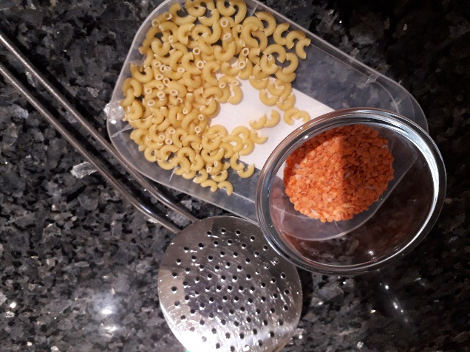

Another way of separating things might be to use a magnet. If you have one thing that is made from metal, and

another that is non metal, then the magnet will pick out the metal things. Look at this picture…
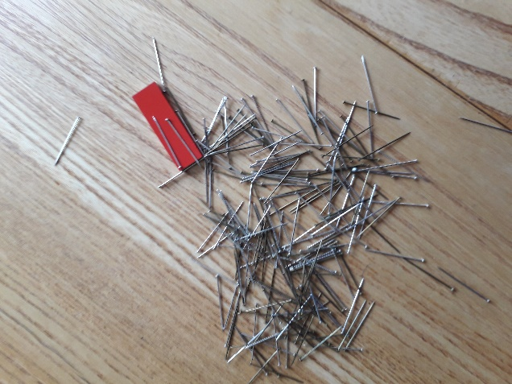.
The magnet picks out the steel pins and leaves the ones that are not made of steel, so I can separate them easily.
It is not always possibly to separate things in the ways we have just tried. Sometimes we have to use methods involving water, like floating and sinking, and dissolving and then trying to get our original material back! But we will look at these ways next time. For now just have a go at separating things, even if it is only a handful of pebbles into different shapes and sizes.
Have fun being a scientist!
Copyright Denise

