March 2021 Activity sheet 7: Sound.

What is sound?

Its all the noises we can hear! There are many different ones, loud and soft, some that might hurt your ears, some very musical.

Lets explore!

Get a grownup to stand beside you - this can be indoors and outside. Shut your eyes and listen. Tell the grownup to write down all the sounds that you tell them you can hear.

Inside you might hear people talking or moving around. They might be making a noise in the kitchen - can you identify these different sounds?

Outside you might hear birds singing, or traffic noise, trains or airplanes. You might hear insects buzzing, more people playing or talking.

We tend to hear more if we listen with our eyes shut! Try it!! You can compare the list!

Make your own Sounds!

Can you make different sounds – can you sing, or whistle? Talk in a whisper or shout?

Everyone likes to make music and there are so many different ways to do this. If you find some drinking glasses or glass bottles you can make different notes of music. Put the glasses or bottles in a line and put different amounts of water in each. Then tap each one with a spoon and you will get musical notes, perhaps you can play a tune!



Use different items from the house – (best from the kitchen if you are allowed!) and bang them – saucepans make lovely drums. Here a plastic container with a wooden spoon makes a lovely drum!



Blow through a comb covered with tissue paper to get another sound!

Some people can play ‘spoons’. Hold two metal spoons of the same size in one hand by the handle. Put a finger between the two handles and you can bang one spoon on to the other - and you can move them together to make a sound. Different sized spoons make different sounds! Get your friends together to make tunes.

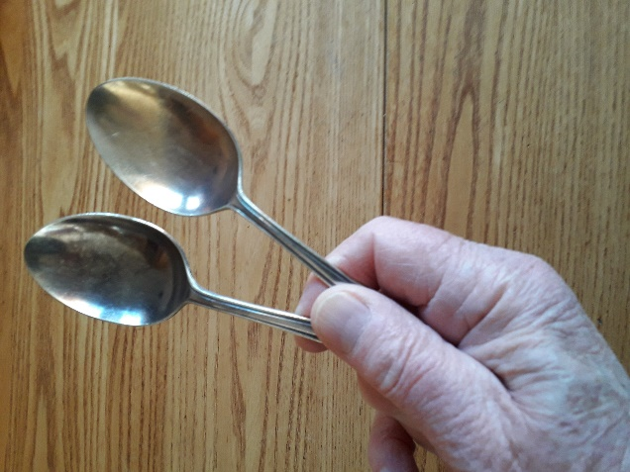

Any metal object will ‘ring’ when banged against another metal object – forks are good, too!

Sounds tend to travel in straight lines – it is easy to hear someone if they call you from across the road. Not so easy if they are behind a building! Make yourself a telephone using two tin cans and some string! Then you will be able to hear round corners! Here’s how. You need two small tins about 400gm size and some string – can be up to 3 metres long. Take the tops off the drinks can and get a grown up to punch a small hole in the bottom end for you. tie a knot in the string and thread through one hole with the knot on the inside of the tin. Thread the string through the second tin from the outside and make a knot on the inside again. Give one tin to a friend and walk away until the string is tight. If they put the tin to an ear, and yo9u talk into your tin, they will hear you! You need to make sure the string is taut (tight). Its magic – your words travel along the string, making it vibrate! Have fun.

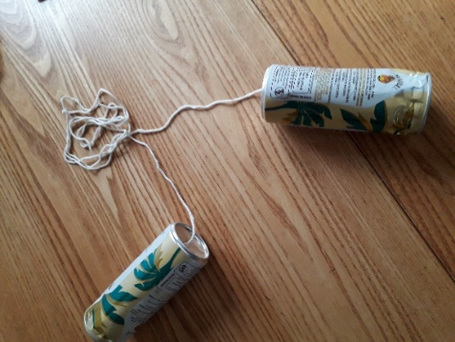

Enjoy making lots of different sounds!

Copyright Denise and Sue