Innovation Activity 12: October 2021
More Separation Ideas
We can separate some things by other ways other than sieving and using magnets. Quite often this involves using water.

Some materials or metals are heavier than others, and we can use the special way gold miners used to find gold in river sediments. Sediments are the muds and little stones found in the bottom of rivers. The gold miners used a method called ‘panning’. (You might like to read about the old gold miners in various countries of the world.)

The idea is to wash away lighter sediments which leaves any heavy pieces in your ‘pan’. A pan can be any lid with a rim. It could be a dustbin lid but these are a bit big but anything of that shape or a shallow pan.

Scoop up some sediment from the bottom of the river or lake with the water. Be careful and get a grown up to help. Gradually swirl the water and sediment so that the water and sediment flow over the edge of the rim. Mind your feet don’t get wet!

Add more water until you get rid of all the fine, light material, and see what you have left in the bottom of your lid. You need to be very lucky to find gold.

In the photos I have used a shiny metal which we use for fun (but its not gold!) you may be lucky and find silvery bits of tin or lead. The gold miners spent weeks panning but very few made their fortunes.

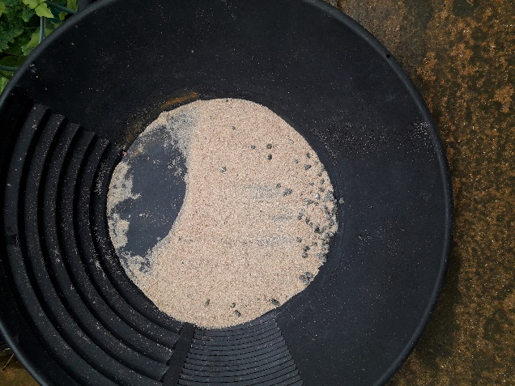

My panning efforts left the heavier mineral in the pan as I washed away the sand.

You can do this even if you don’t live near a river or any water. Perhaps someone can give you some small pieces of metal which you can cover with sand then try to recover them by using water to wash away the sand. Try it, its fun!

Things that disappear or dissolve in water.
If you add sugar or salt to water and stir, the sugar and salt will seem to disappear. It ‘dissolves’ into the water so you cannot see it. but if we are careful we can get it back.

Pour some of the salt or sugar liquid onto a saucer and put in a warm place – perhaps in the sunshine on a window ledge. It takes perhaps several days but the water will evaporate and leave the salt or sugar behind – taste it! it probably won’t look exactly like the crystals you put into the water, but will be much smaller crystals. The longer the water takes to evaporate the larger your tiny crystals will be.

(Do you remember that ‘evaporate’ means when the water changes into water vapour gas?)
You cannot get everything that dissolves in water back, sadly. And the sugar or salt won’t look quite the same, but it will taste the same.
If you are very careful you can grow crystals in water but this is quite tricky.
I put some Epsom salts (magnesium sulphate an eye wash) in a glass of very hot water. the same amount of the Epsom Salts as the volume of water. I stirred this until all the salt had ‘gone’ and the water was clear. I left it for 2 weeks and eventually got lots of crystals. You have to be very patient!

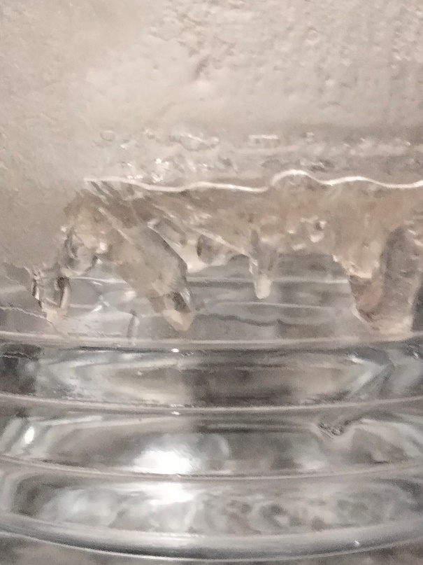

You can see the pointed crystals in the middle of the picture.
You can use ordinary cooking salt but it might take ev3n longer to get crystals!

Have fun trying out different separation methods!!

Copyright Denise 2021

